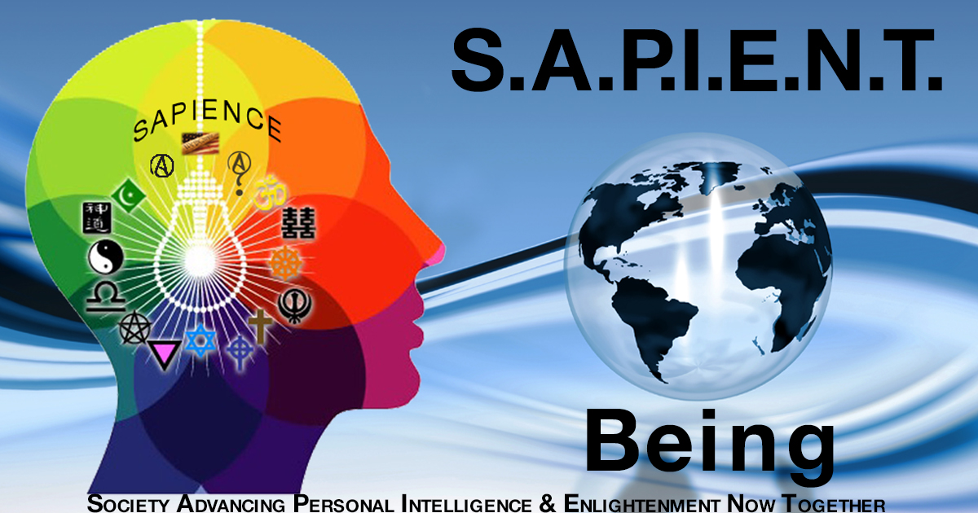

SAPIENT Being
(xxx CLUB or xxx CHAPTER or xxx ALLIANCE
PROPOSAL)
at
(SCHOOL NAME)

INTRODUCTION
The SAPIENT BEING (Society Advancing Personal Intelligence & Enlightenment Now Together) is a new education based organization approved by the IRS on 4-16-19 as a non-profit 501 c (3) charity with tax deductible donation status. It’s primary project goal on campus is to Make Free Speech Again on Campus by creating the premier freedom of speech and expression activist organization to increase civic engagement and address free speech violations and code ambiguities endemic in many of our educational systems.
SAPIENT BEING VISION & MISSION STATEMENTS

The SAPIENT BEING’S vision is to return free speech, open dialogue and civil discourse to school campuses without intimidation and threat of violence to those with differences in opinion, ideologies and practices; and encourage open debate and dialogue and free expression of alternative and different viewpoints with the goal of creating a society advancing personal intelligence and enlightenment now together along with leaders to implement and accomplish it.

The SAPIENT BEING’S mission is to provide our students and leaders the opportunity to start SAPIENT Being campus (INSERT clubs, OR chapters OR alliances) where independent, liberal and conservative minded students can meet safely and debate relevant facts and discover the truth about the important issues facing us today and become leaders in the process by practicing, protecting and promoting free speech and its principles.

SAPIENT BEING at (SCHOOL NAME)
ORGANIZATION GOALS:

The SAPIENT Being’s primary goal is to return or protect free speech to campus by assessing and revising our school’s free speech policy by creating opportunities for open dialogue and self-examination that ensures first amendment rights for freedom of speech and expression are fully enforced. We are a non-profit, non-partisan, non-religious, and non-sectarian organization that subscribes to only one ideology; which is human sapience (wisdom); and welcome with open minds, arms and hearts the believers and practitioners from all ideologies, faiths and walks of life.

BENEFITS OF HAVING a SAPIENT BEING
ORGANIZATION on CAMPUS:

This is a perfect opportunity for consensus building between liberal and conservative leaning students to come together and openly debate the hottest and most contentious issues facing America and the world today. The SAPIENT BEING also provides a great venue and resource center for independent minded students who want to hear both sides of an issue, from any topic, without intimidation. We accomplish this by following the highest standards of civil discourse and debating formats that respect other’s ideas, premises and principles without attacking their character with malice and prejudice.

SAPIENT BEING at (SCHOOL NAME)
EXECUTIVE BOARD

Position | Name | Class | Major
Chapter President
Chapter Vice President
Chapter Treasurer
Chapter Secretary
Social Media Director

INTEREST on CAMPUS:

AS OF TODAY (NUMBER) STUDENTS ON CAMPUS HAVE SIGNED UP TO JOIN SAPIENT BEING. THE FULL LIST OF STUDENTS CAN BE PROVIDED AS REQUESTED.

